**Supplementary File**

**Adaptive laboratory evolved MRSA with PPEF manifest cross-susceptibility to oxacillin and hypersensitivity to ciprofloxacin**

#Vikas Maurya1, #Raja Singh2, Shruti Kutmutia3, Bibha Chaudhary4, Souvik Bhattacharjee1,*Vibha Tandon1,5

**Affiliations**

1Special Centre for Molecular Medicine, Jawaharlal Nehru University, New Delhi-110067, India.

2Department of Microbiology and Immunology, Emory University, Atlanta, USA.

3Bacalt Biosciences Private Limited, Bengaluru, Karnataka-560100, India.

4Institute of Bioinformatics and Biotechnology, Bangaluru-560100, India.

5CSIR-Indian Institute of Chemical Biology, Kolkata, West Bengal-700032, India.

#Contributed equally

*Corresponding author

Vibha Tandon

Director, (On deputation from JNU)

CSIR- Indian Institute of Chemical Biology, Kolkata- 700032, India

Email Id: [vtandon@iicb.res.in](mailto:vtandon@iicb.res.in), [vtandon@mail.jnu.ac.in](mailto:vtandon@mail.jnu.ac.in)

Telephone number: +91 9313583818

Table S1. qRT-PCR primer details.

Table S2. Quality control metrics of transcriptomics of *S. aureus* 25923 and 43300 evolved strains.

Table S3. Quality control metrics of genomic analysis of *S. aureus* 25923 and 43300 evolved strains.

Table S4. Fractional Inhibitory Concentration Index of PPEF in combination with Ciprofloxacin.

Fig. S1. Gram staining of PPEF evolved *S. aureus* strains.

Fig. S2. Quality validation and analysis of SA-GC and SA-PR raw reads using FastQC.

Fig. S3. Quality validation and analysis of MRSA-GC and MRSA-PR raw reads using FastQC.

Fig. S4. Distributions of unique genes per spot visualized as violin plots using the RNAseq data set of the SA and MRSA reads.

Fig. S5. Systematic evaluation of RNA-seq data of *S. aureus* 25923 and 43300 evolved strains.

Fig. S6. Fold-change versus normalized mean counts for *S. aureus* 25923 and 43300 evolved strains.

Fig. S7. Differential expression profile for MRSA-PR and SA-PR.

**Table S1. qRT-PCR primer details.**

|  |  |  |  |
| --- | --- | --- | --- |
| **Sr. No.** | **Gene name** |  | **Virulence gene qRT-PCR sequence** |
|  |  |  |  |
| 1 | *spa* | Fp | 5΄-GCGTAACACCTGCTGCAAAT-3΄ |
| Rp | 5΄-AGAAGGCGCTTTGTTGATCT-3΄ |
|  |  |  |  |
| 2 | *coa* | Fp | 5΄-GTCCGAGACCGCAATTTAACA-3΄ |
| Rp | 5΄-TGTGCCATCTTGATTTGTCGT-3΄ |
|  |  |  |  |
| 3 | *hla* | Fp | 5΄-GGTGCAAATGTTTCGATTGGTC-3΄ |
| Rp | 5΄-TGCCATATACCGGGTTCCAA-3΄ |
|  |  |  |  |
| 4 | *fnbA* | Fp | 5΄-TGGCACAGCCAAGAACGGCA-3΄ |
| Rp | 5΄-TGTACCCGTTTCCACTTTCGCGT-3΄ |
|  |  |  |  |
| 6 | *icaA* | Fp | 5΄-ACACTTGCTGGCGCAGTCAA -3΄ |
| Rp | 5΄-TCTGGAACCAACATCCAACA-3΄ |

|  |  |  |  |
| --- | --- | --- | --- |
| **Sr. No.** | **Gene name** |  | **qRT-PCR sequence** |
|  |  |  |  |
| 1 | *topA* | Fp | 5΄-TGGAGGAAAGTAATCGACGGT-3΄ |
| Rp | 5΄-GGGAAGTTTGAGCAAGCCAT-3΄ |
|  |  |  |  |
| 2 | *topB* | Fp | 5΄-ATGCTGGACGAGAAGGTGAA-3΄ |
| Rp | 5΄-CAATCTGCCTCACTTCTCGC-3΄ |
|  |  |  |  |
| 3 | *mecR1* | Fp | 5΄-agtcgaaaccatgaatgacaa-3΄ |
| Rp | 5΄-cgtatatgttcatggcgattca-3΄ |
|  |  |  |  |
| 4 | *atpD* | Fp | 5΄-TCTGTATTCGCCGGTGTAGG-3΄ |
| Rp | 5΄-ACCTCAGAACCAGCTTGTGT-3΄ |
|  |  |  |  |
| 5 | *kdpB* | Fp | 5΄-aacaatgtcatgcttggcgT-3΄ |
| Rp | 5΄-atcaaccccggcttcttttg-3΄ |
|  |  |  |  |
| 6 | *norB* | Fp | 5΄-ATGTTTGTCGTTGGAGCAGG-3΄ |
| Rp | 5΄-AATACACGCTGCTGATAGGC-3΄ |
|  |  |  |  |
| 7 | *femA* | Fp | 5΄-AACTGTTGGCCACTATGAGT-3΄ |
| Rp | 5΄-CCAGCATTACCTGTAATCTCG-3΄ |

**Table S2. Quality control metrics of transcriptomics of *S. aureus* 25923 and 43300 evolved strains**. The overall quality of RNAseq data was satisfied at the level of raw reads with high phred score across all bases at each position in the FASTQ file of all the samples and the average GC content of the data generated from all samples was around 35%.

|  |  |  |  |  |  |  |  |
| --- | --- | --- | --- | --- | --- | --- | --- |
| **Sample** | **Raw reads (bp)** | **Raw data**  **(Gb)** | **Effective (%)** | **Error (%)** | **Q20**  **(%)** | **Q30**  **(%)** | **GC**  **(%)** |
| SA-GC_I | 92831826 | 13.9 | 98.78 | 0.03 | 97.97 | 93.59 | 35.25 |
| SA-GC_II | 87205474 | 13.1 | 97.33 | 0.03 | 97.43 | 92.53 | 35.18 |
| SA-PR_I | 98583252 | 14.8 | 98.87 | 0.03 | 97.13 | 92.00 | 37.50 |
| SA-PR_II | 104570890 | 15.7 | 98.87 | 0.03 | 97.17 | 92.06 | 34.80 |
| MRSA-GC_I | 89415452 | 13.4 | 98.79 | 0.03 | 97.24 | 92.23 | 35.76 |
| MRSA-GC_II | 94665120 | 14.2 | 98.90 | 0.03 | 97.03 | 91.58 | 35.00 |
| MRSA-PR_I | 85600214 | 12.8 | 98.84 | 0.03 | 96.96 | 91.61 | 35.52 |
| MRSA-PR_II | 88637270 | 13.3 | 98.17 | 0.03 | 97.82 | 93.28 | 35.10 |

**Table S3**. **Quality control metrics of genomic analysis of *S. aureus* 25923 and 43300 evolved strains**. The overall quality of Next-Generation Sequencing (NGS) data was satisfied at the level of raw reads with high phred score across all bases at each position in the FASTQ file of all the samples and the average GC content of the data generated from all samples was around 35%.

|  |  |  |  |  |  |  |
| --- | --- | --- | --- | --- | --- | --- |
| **Sample** | **Reads**  **(bp)** | **Effective**  **(%)** | **Error**  **(%)** | **Q20**  **(%)** | **Q30**  **(%)** | **GC**  **(%)** |
| SA-GC | 10301714 | 99.88 | 0.03 | 97.55 | 92.88 | 32.95 |
| SA-PR | 8397228 | 99.89 | 0.03 | 97.48 | 92.76 | 32.9 |
| MRSA-GC | 10574464 | 99.82 | 0.03 | 96.36 | 90.44 | 32.83 |
| MRSA-PR | 9678624 | 99.9 | 0.03 | 97.27 | 92.3 | 32.87 |

**FIG S1. Gram staining of *S. aureus* ATCC 25923 and 43300 evolved strains.**

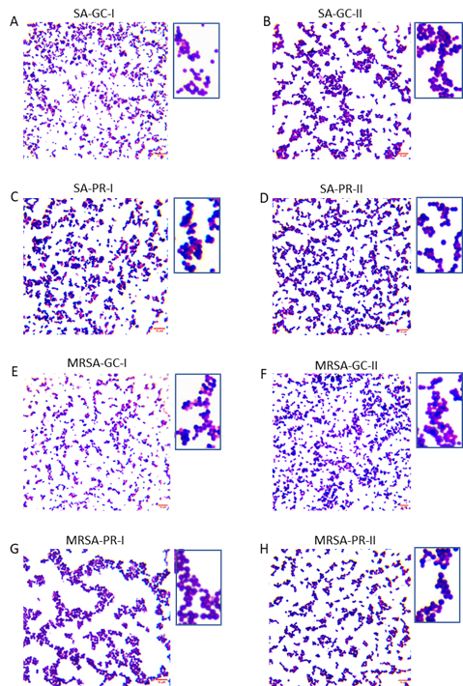

**FIG S1.** Gram stained smears of *S. aureus* ATCC 25923 evolved strain with and without PPEF (A-D) respectively**.** Gram stained smears of *S. aureus* ATCC 43300 evolved strain with and without PPEF (E-H) respectively.The respective scale bar for the images is 10 µm.

**FIG S2. Quality validation and analysis of SA-GC and SA-PR raw reads using FastQC.**  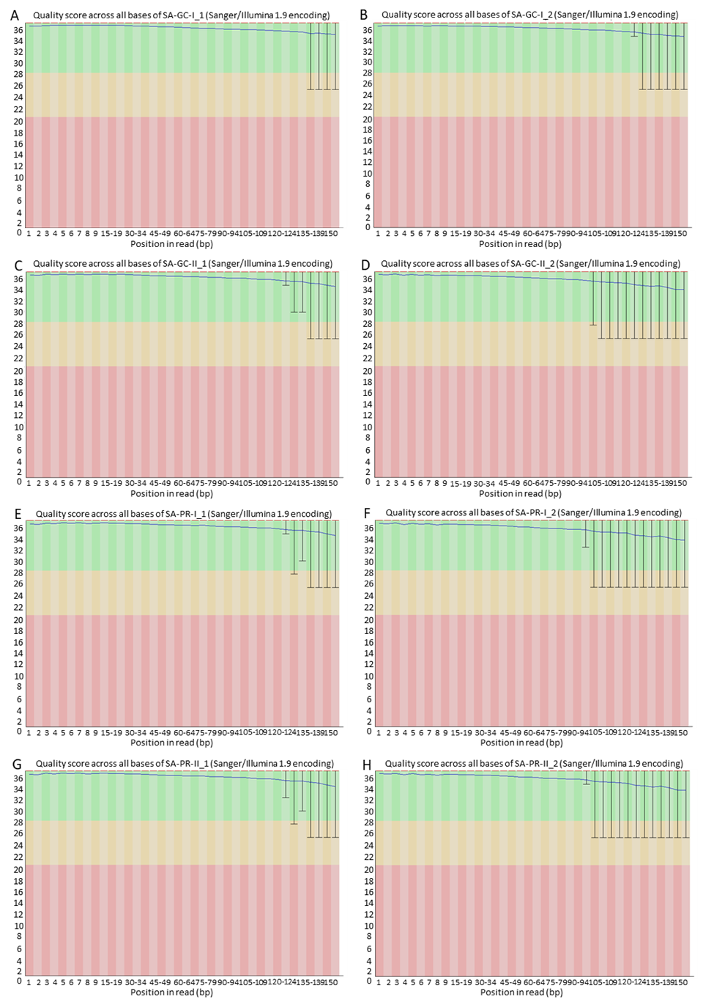



**FIG S2**. The Next-Generation Sequencing (NGS) generated raw reads underwent examination for quality assessment with FastQC (version 0.11.3). Reads were pre-processed to remove the adapter sequences and removal of the low-quality bases (>q30). (**A, B**) Average base quality of R1 and R2 reads of SA-GC-I. (**C, D**) Average base quality of R1 and R2 reads of SA-GC-II. (**E, F**) Average base quality of R1 and R2 reads of SA-PR-I. (**G, H**) Average base quality of R1 and R2 reads of SA-PR-II. The x-axis represents the position in the read, while the y-axis depicts the Q-score. The median value Q-score is denoted by the red line, and the mean value Q-score is represented by the dark blue line. Data with a Q-score above 30 (>99.9% correctness) is considered high quality.

**FIG S3. Quality validation and analysis of MRSA-GC and MRSA-PR raw reads using FastQC.**

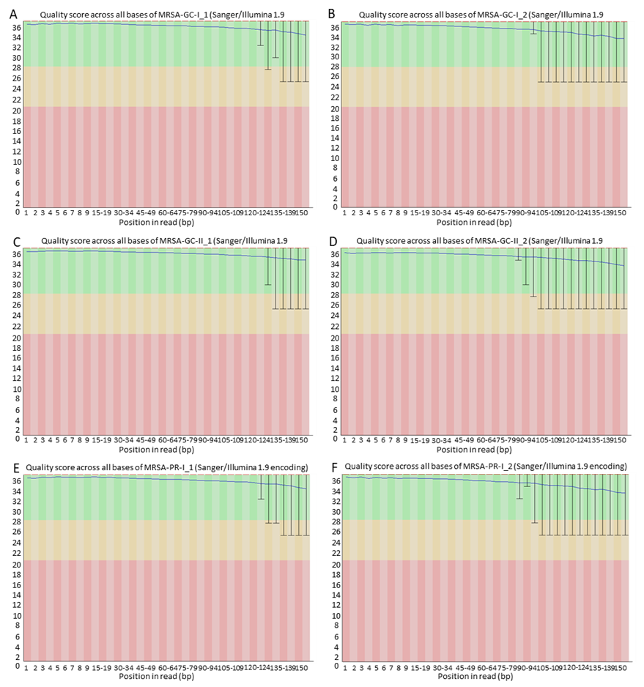

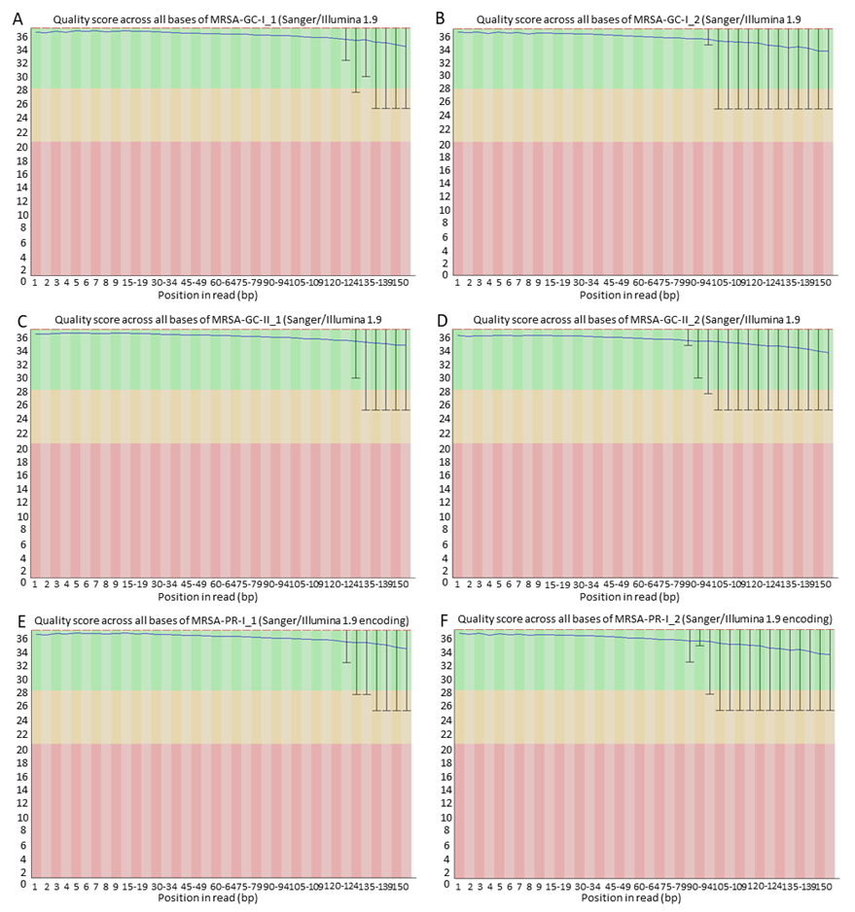

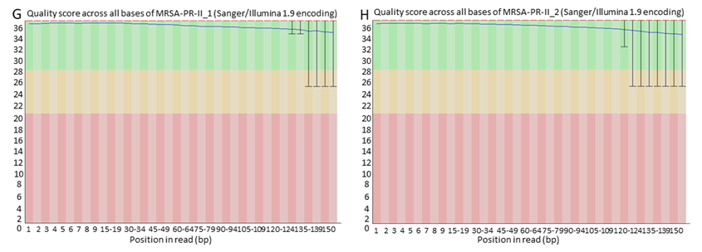

**FIG S3.** The Next-Generation Sequencing (NGS) generated raw reads underwent examination for quality assessment with FastQC (version 0.11.3). Reads were pre-processed to remove the adapter sequences and removal of the low-quality bases (>q30). (**A, B**) Average base quality of R1 and R2 reads of MRSA-GC-I. (**C, D**) Average base quality of R1 and R2 reads of MRSA-GC-II. (**E, F**) Average base quality of R1 and R2 reads of MRSA-PR-I. (**G, H**) Average base quality of R1 and R2 reads of MRSA-PR-II. The x-axis represents the position in the read, while the y-axis depicts the Q-score. The median value Q-score is denoted by the red line, and the mean value Q-score is represented by the dark blue line. Data with a Q-score above 30 (>99.9% correctness) is considered high quality.

**FIG S4. Distributions of unique genes per spot visualized as violin plots using the RNAseq data set of the SA and MRSA reads.**

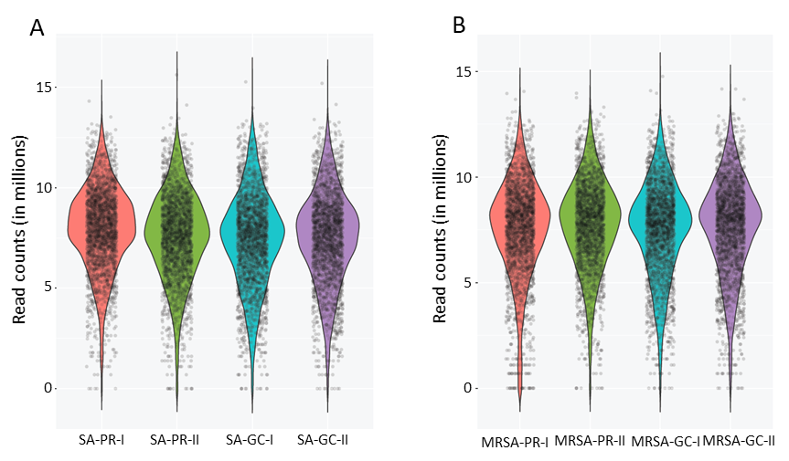

**FIG S4.** Violin plot showing the pattern of read counts along the elevational gradient. The violin frame shows the kernel density of the data distribution. Box whisker plot inside the violin plot represents the degree of dispersion for (A) SA-PR, SA-GC and (B) MRSA-PR, MRSA-GC.

**FIG S5. Systematic evaluation of RNA-seq data of *S. aureus* ATCC 25923 and 43300 evolved strains**.

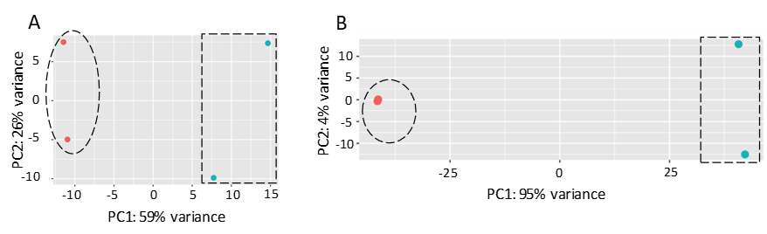

**FIG S5.** Principal component analysis (PCA) analysis of RNA-seq data to visualize sample to sample variation. The PCA plot depicted clear clustering for (A) control (SA GC, shape-circle) versus PPEF evolved strain (SA-PR, shape-rectangle) and (B) control (MRSA-GC, shape-circle) versus PPEF evolved strain (MRSA-PR, rectangle). The first components PC1 and PC2 explained 26%, 59%, 4% and 95% variability in the expression data of SA and MRSA respectively.

**FIG S6. Fold-change versus normalized mean counts for *S. aureus* ATCC 25923 and 43300 evolved strains.**

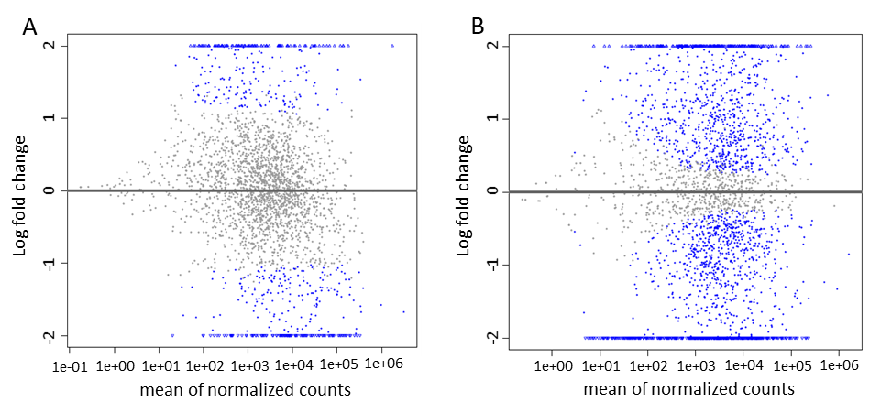

**FIG S6.** MA plot displaying the log fold change compared with mean expression using a DESeq2 data set of the SA and MRSA reads with default log fold change thresholds of -1 and 1. This is displayed as scatter plot with base-2 log fold change along the y-axis and normalized mean expression along the x-axis. Data points with extreme values along y axis represent the genes that have highly differential expression levels. A high number of data points falling above the one threshold on the y axis indicate a more significant number of genes being upregulated and more below -1 indicate high level of downregulation in genes for MRSA (B) in comparison to SA (A).

**FIG S7. Differential expression profile for MRSA-PR and SA-PR.**

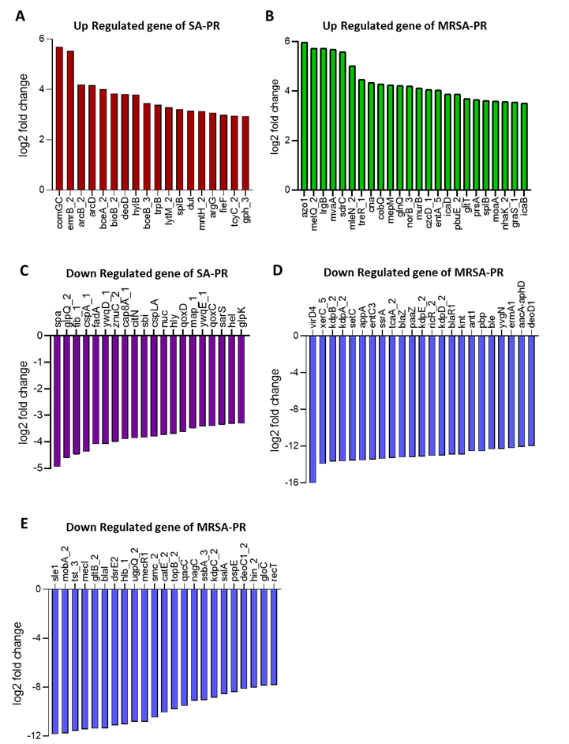

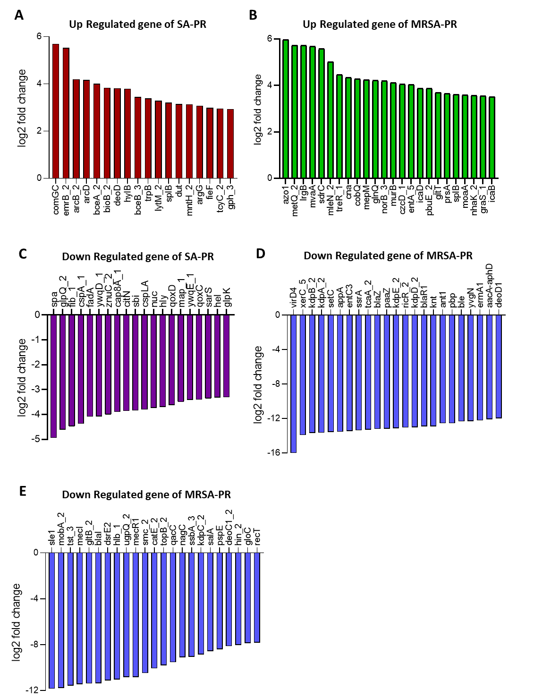

**FIG S7.** A.Upregulated genes of SA-PR (Red in color) B. Upregulated genes of MRSA-PR (Green in color) C. Down regulated genes of SA-PR (Purple in color) and D Down regulated genes of MRSA-PR (Blue in color).

**Table S4**. **Fractional Inhibitory Concentration Index of PPEF in combination with Ciprofloxacin.**

|  |  |  |  |  |  |  |
| --- | --- | --- | --- | --- | --- | --- |
| **Bacteria** | **PPEF (A)**  **MIC μg/mL** | **CIP (B)**  **MIC μg/ mL** | **(AB)**  **MIC μg/mL** | **(BA)**  **MIC μg/mL** | **FICI** | **Interpretation** |
| SA-GC | 0.5 ± 0.09 | 0.25 ± 0.08 | 0.5 ± 0.4 | 1.0 ± 0.7 | 1.5 | Indifferent |
| SA-PR | 32 ± 0.05 | 0.25 ± 0.5 | 1.0 ± 0.3 | 1.0 ± 0.8 | 2 | Indifferent |
| MRSA-PR | 32 ± 0.28 | 0.25 ± 0.02 | 1.0 ± 0.4 | 1.0 ± 0.7 | 2 | Indifferent |